**Experiment 7**

**Aim:** Write a Shell Scripts to find factorial of given number (both methods).

**Software:** Ubuntu

**Procedure:**

* Using command #gedit create a file with .sh extension
* Enter the given Shell Script in the file.
* Using method 1

echo "Enter a number to find factorial"

read num

fact=1

while [ $num -gt 1 ]

do

fact=$((fact*num))

num=$((num-1))

done

echo $fact

* Using method 2

echo "Enter a number"

read num

fact=1

for((i=2; i<=num; i++))

{

fact=$((fact*i))

}

echo $fact

* Use commands #chmod +x filename.sh to give execution rights to the file.
* Then enter the number for which you want to find factortal.
* Output gets displayed.

**Output:**

**Method 1)**

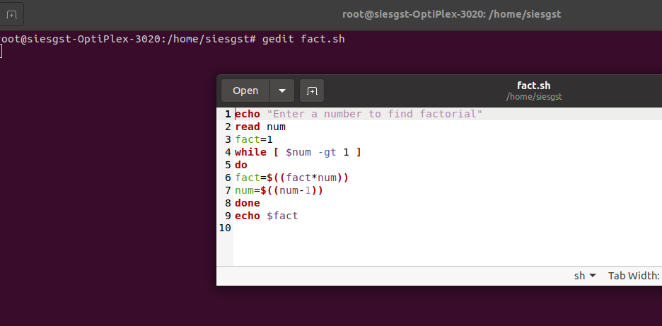

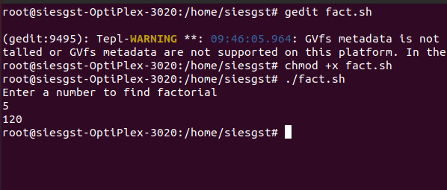

**Method 2)**

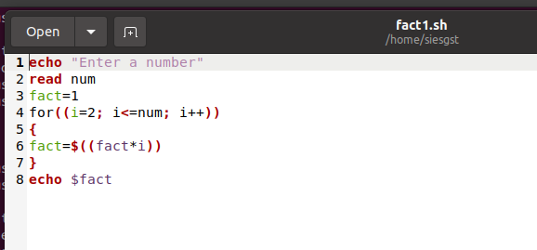

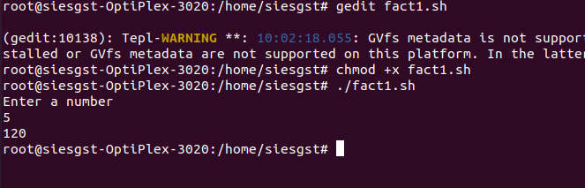

**Conclusion:**

The Shell Scripts to find factorial of given number (both methods) was performed successfully. Students were able to find factorial using both methods ie using for and while loop.